# Machine Learning Model Tracking Document

## 1. Dataset Information

|  |  |
| --- | --- |
| Dataset Name: | Well 160 |
| Number of Samples: | 160 |
| Number of Features: | 4 (Tf, Rs, Gg, Api) |
| Target Variable: | Pb |
| Outlier Handling: | None |
| Feature Engineering Applied: | None |
| Scaling/Normalization Applied: | Only for Neural Networks |
| Encoding Applied: | None |

## 2. Preprocessing Steps

|  |  |
| --- | --- |
| Step | Description |
| Train-Test Split | 70% - 30% |
| Shuffling | Yes, using random_state=42 |
| Handling Missing Data | None |
| Feature Scaling | Only for Neural Networks |
| Feature Selection | None |

## 3. Models Used & Hyperparameters

|  |  |  |
| --- | --- | --- |
| Model | Hyperparameters | Training Time |
| **XGBoost** | n_estimators=200, learning_rate=0.1, max_depth=4 | 0.0252 |
| **CatBoost** | iterations=1000, learning_rate=0.1, depth=4, l2_leaf_reg=7 | 0.1036 |
| **Neural Network** | [128, 64, 32], epochs=150, batch_size=32 | 3.4472 |
| **Stacking Ensemble** | Default base models + CatBoost final estimator | 0.4703 |
| **Extra Trees** | n_estimators=200 | 0.0569 |
| **Deep Neural Network** | [256, 128, 64], epochs=150, batch_size=16 | 3.4314 |

## 4. Evaluation Metrics

|  |  |  |  |  |  |
| --- | --- | --- | --- | --- | --- |
| Model | MSE | RMSE | MAE | R² Score | Adjusted R² |
| **XGBoost** | 13412.360 | 115.812 | 83.490 | 0.9902 | 0.9892 |
| **CatBoost** | 22057.603 | 148.518 | 86.771 | 0.9838 | 0.9823 |
| **Neural Network** | 58507.281 | 241.883 | 176.604 | 0.9571 | 0.9531 |
| **Stacking Ensemble** | 15595.798 | 124.883 | 79.742 | 0.9886 | 0.9875 |
| **Extra Trees** | 21312.234 | 145.987 | 93.944 | 0.9844 | 0.9829 |
| **Deep Neural Network** | 18709.108 | 136.781 | 90.925 | 0.9863 | 0.9850 |

## 5. Cross-Validation Summary (5-Fold)

|  |  |  |  |  |  |  |
| --- | --- | --- | --- | --- | --- | --- |
| Model | RMSE Mean | RMSE Std | MAE Mean | MAE Std | R² Mean | R² Std |
| **Stacking Ensemble** | 119.651 | 24.637 | 81.829 | 15.582 | 0.9867 | 0.0053 |
| **CatBoost** | 122.980 | 35.282 | 76.138 | 14.875 | 0.9854 | 0.0090 |
| **Extra Trees Regressor** | 136.914 | 23.415 | 97.075 | 9.053 | 0.9826 | 0.0076 |
| **XGBoost** | 142.822 | 26.733 | 97.016 | 13.295 | 0.9813 | 0.0070 |
| **Deep Neural Network** | 531.527 | 117.639 | 409.308 | 89.067 | 0.7317 | 0.1421 |
| **Neural Network** | 593.133 | 128.666 | 464.182 | 100.915 | 0.6587 | 0.1796 |

## 6. Visualizations

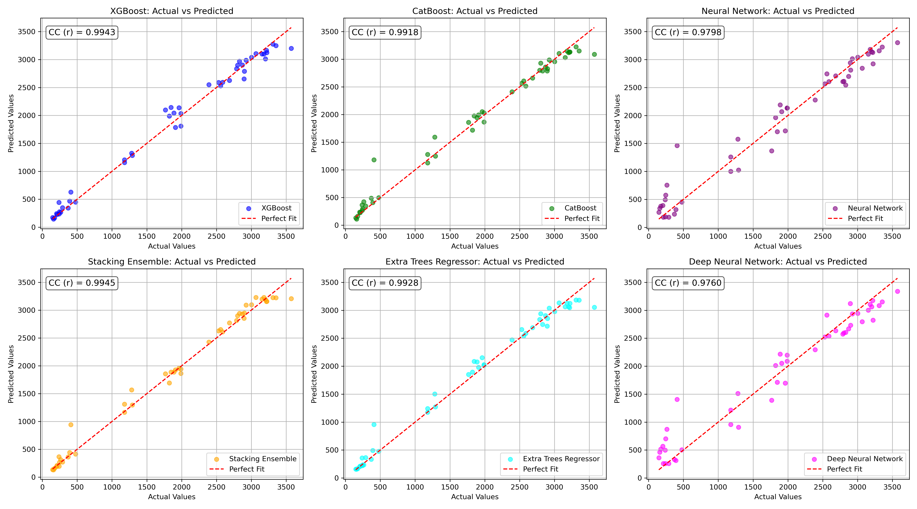

*Figure 1: Actual vs. Predicted Values for Pb (Well 160)*

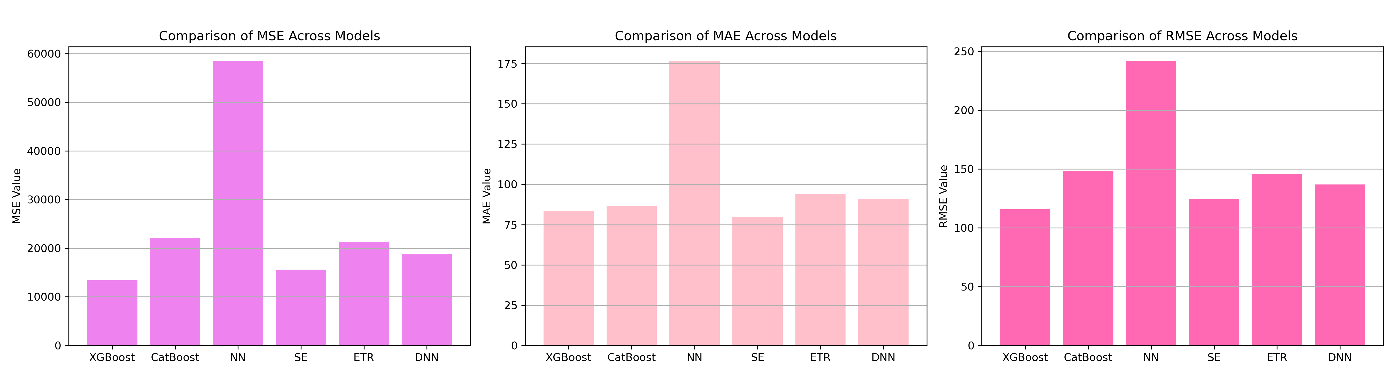

*Figure 2: Bar Charts of MSE, RMSE, MAE for Pb (Well 160)*

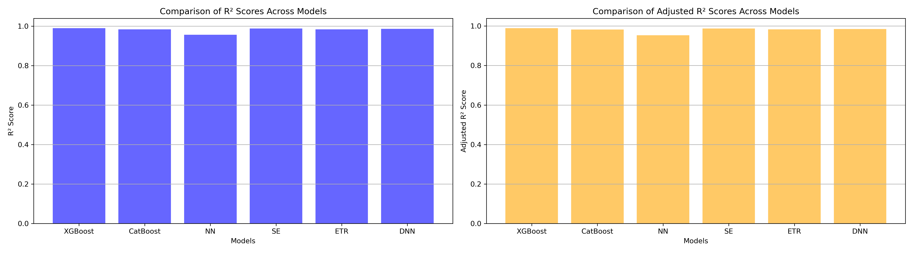

*Figure 3: Bar Charts of R² and Adjusted R² for Pb (Well 160)*

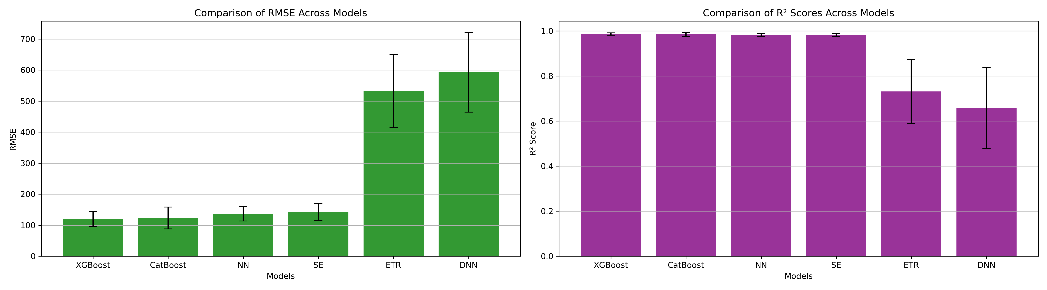

*Figure 4: Error Bars for RMSE and R² from CV for Pb (Well 160)*

### 7. Observations & Next Steps

**Best Performing Model:** **Stacking Ensemble** (RMSE ~124.88, R² ~0.9886)

* XGBoost and CatBoost also performed strongly but slightly behind the stacking model.
* **Neural Networks (NN and DNN)** performed poorly compared to ensemble methods.
  + Deep learning models showed much higher RMSE and lower R².
  + Particularly bad generalization across folds in cross-validation (high RMSE, unstable R²).
* Small sample size (~160) limits the effectiveness of neural networks.

### 8. Code Access

The complete source code for data preprocessing, model training, evaluation, and visualization is [available here.](http://github.com/BoushBoo/pvt-prediction-ml-/tree/main) The repository includes organized Jupyter notebooks for each phase, dataset, and target, as well as requirements for reproducibility.